|  |  |
| --- | --- |
| Name: | Class: |



**➀ Listen and circle.** Score / 10



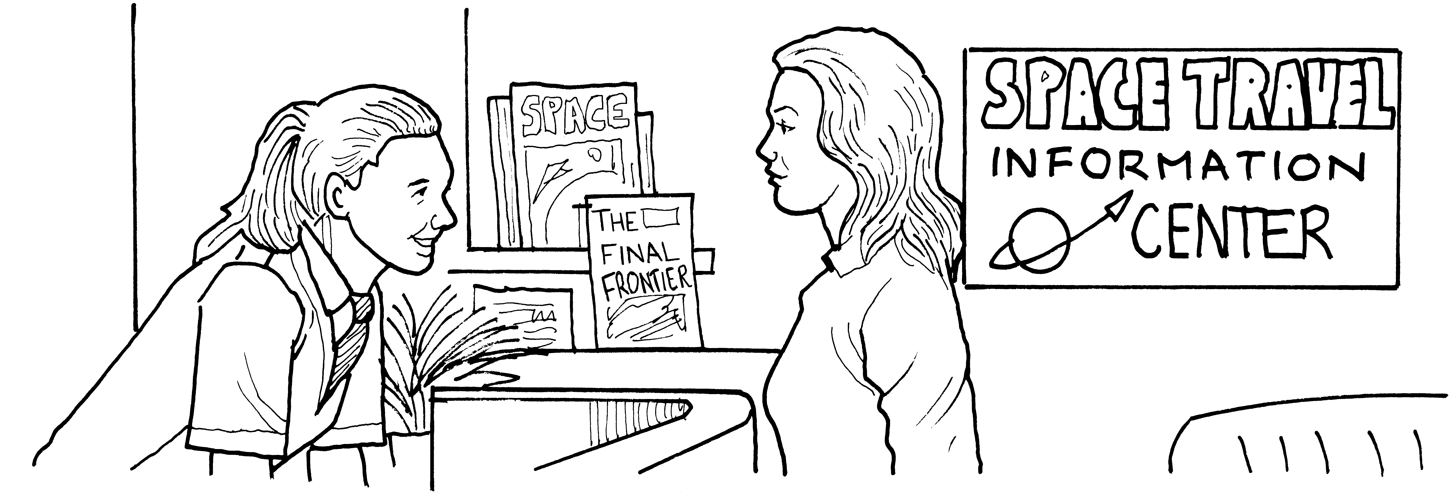➊ She will be able to see Earth and Mercury / Venus.

➋ There is a lot of space / food in the rocket.

➌ The flight will be four / five hours.

➍ They will eat vegetables / meat.

➎ They will read or take pictures / listen to music in the evenings.

➏ The woman will / won’t go to space.

**➁Read and match.** Score / 5

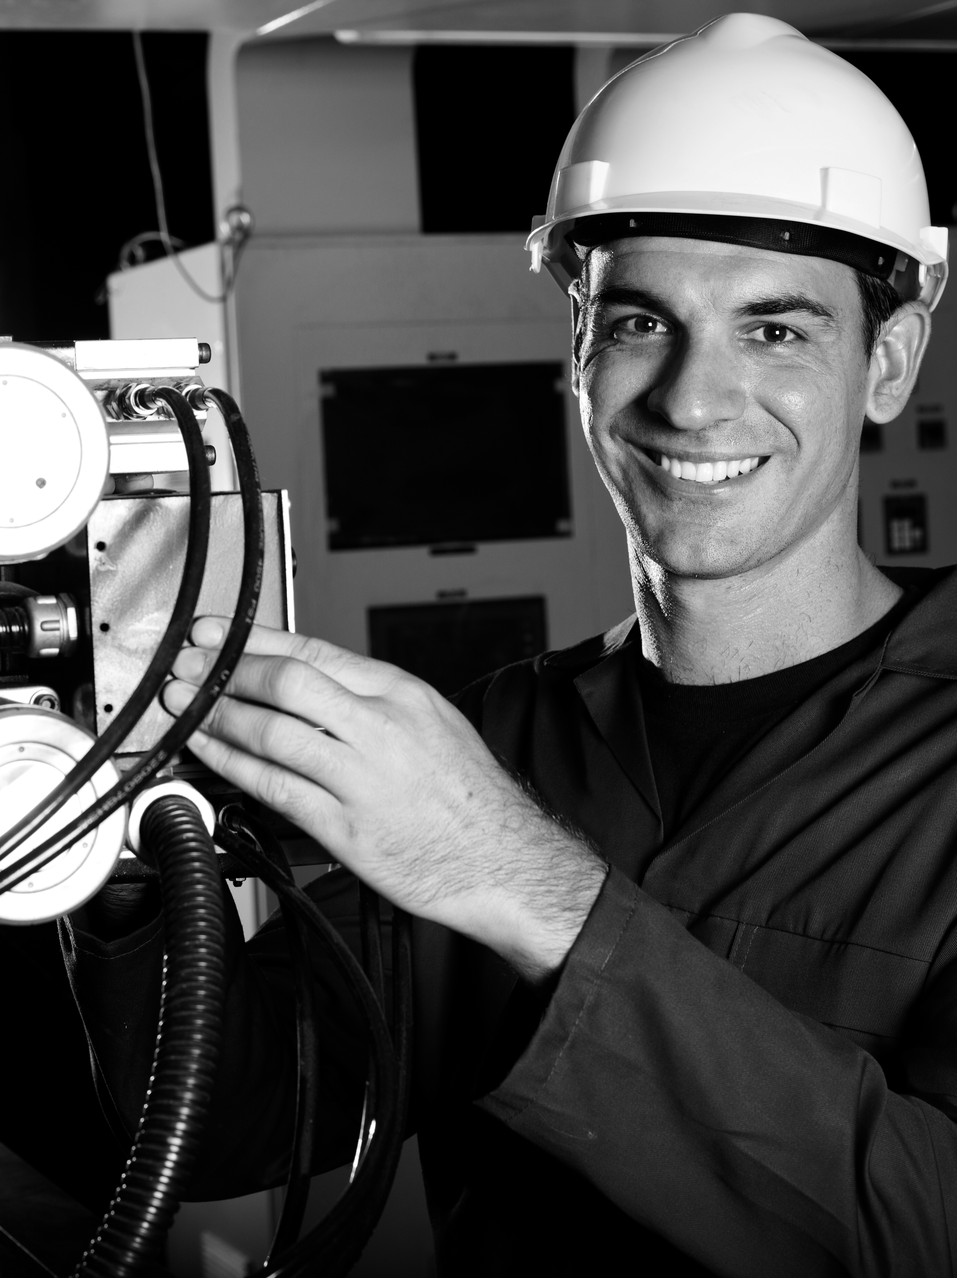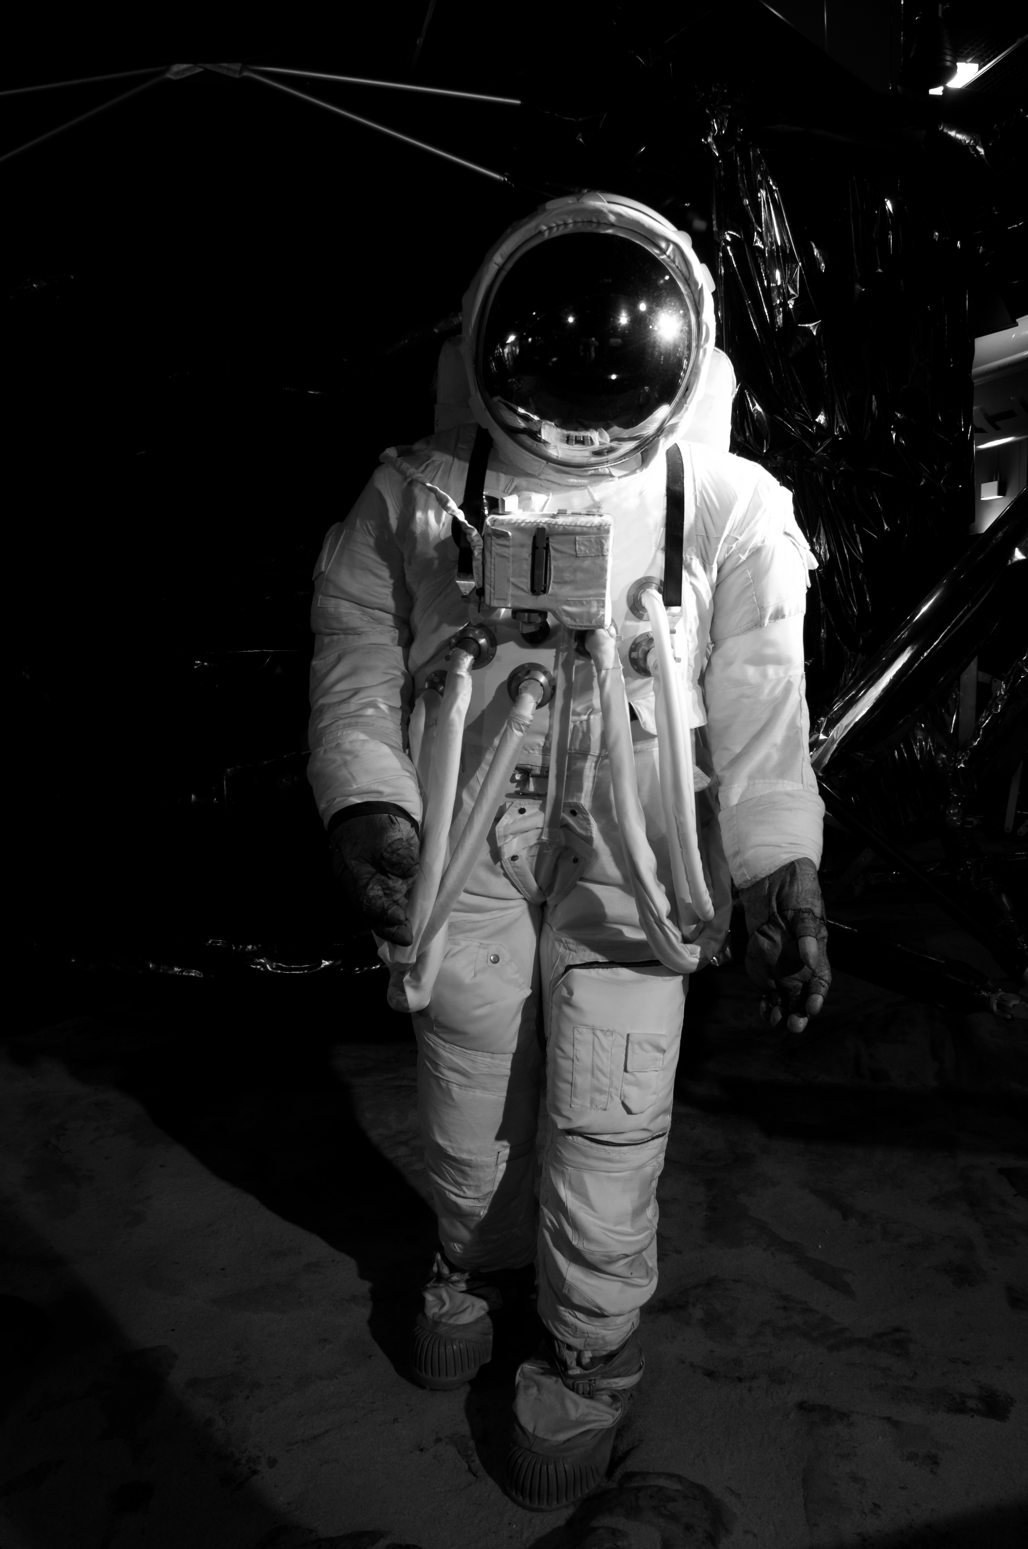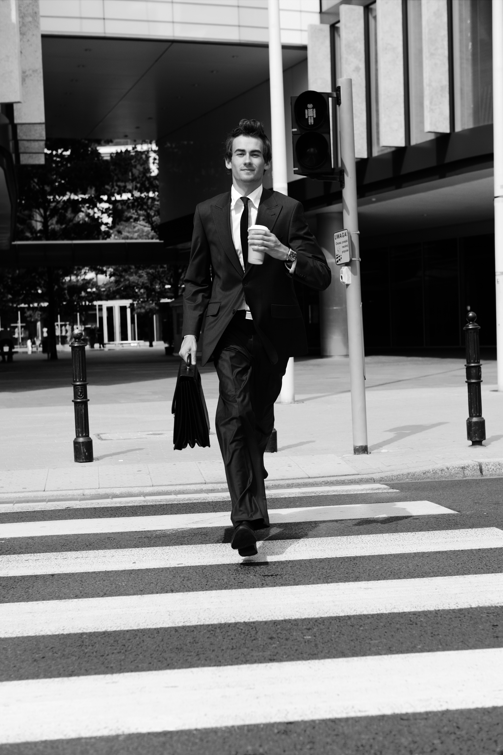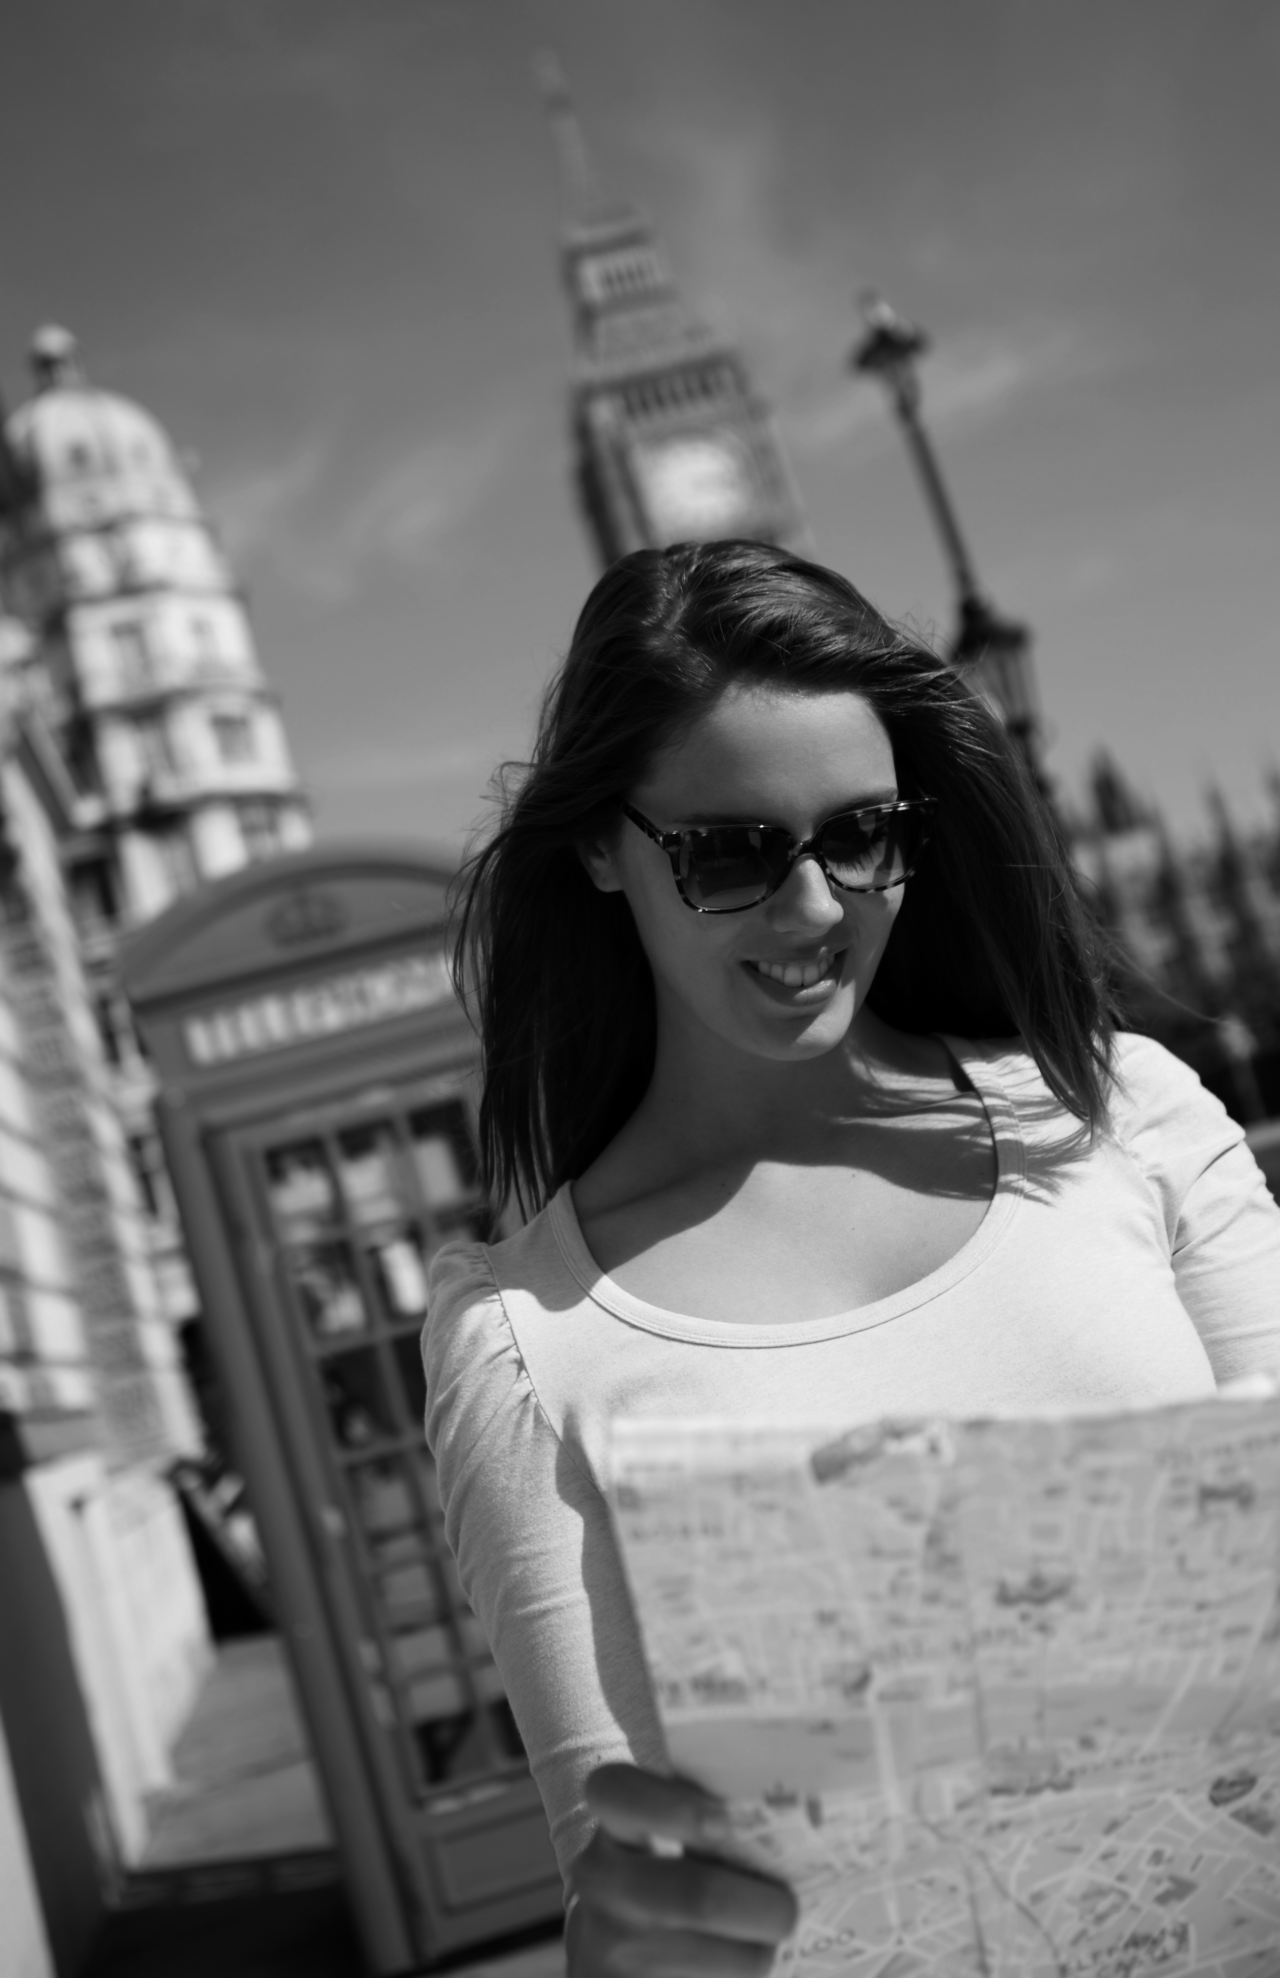 **a b c d**

➊ My job is amazing.

Not a lot of people will go to space this year, but I will! c

➋ I work at NASA, but I don’t go to space.

I work with rockets here on Earth. _

➌ Today I’m in London, but one day I’ll be a space tourist! _

➍ I’m very excited!

Tomorrow, I will travel in a rocket for the first time. _

➎ I work in the city, but I won’t work here all my life.

I’ll live in the country in the future. _

➏ I don’t know when I’ll go home.

I want to travel around England for a long time. _

Total unit score / 15